INTERIM REPORT   
FOR THE

**FLEET MANAGEMENT & ONLINE RESERVATION SYSTEM**

K180875 : Kasun Tharaka

K151631 : Arshjot Kaur

K170595 : Navdeep

K180582 : Bikash Bhandari

Table of Contents

Project Overview 3

Project Scope 3

Budget 4

Technology & Development 5

Project Time Schedule 7

Risk Management 9

# Project Overview

The vehicle fleet management and reservation system is to be developed for a Car Rental Company which is growing up business in Europe and Australia. At this stage, company handle those activities by using manual and effortless systems. This web based system will provide better accessible, modernize, flexible and efficient service for their customers, as same as for the staff of the company.

Fleet management & reservation business solution will provide the features for customers mainly,

* Customer registration and modify personal limited details
* Make a reservation on selected vehicle (one at once) with excess services

The system will provide the facility for the company staff except administration or high level management of the business,

System login (login will provide by management)

* Customer registration (view & edit) and reservations
* Check upcoming pickups and dropping off
* Make an agreement
* Offer discount prices (terms & conditions apply)

As well as, the administration will have the features all in above and,

* Register or add staff members
* Add / edit / delete fleet details
* Add / edit / delete extra services
* View & manage inventory
* Vehicles’ registration expiry alert

# Project Scope

Manage

Staff

Customer

C:\Program Files (x86)\Microsoft Office\MEDIA\CAGCAT10\j0292982.wmf

Access

Registration

Select

Manage

Raw Data

Manage

Full Manage

View Reports

Manage

Administration

Vehicles

The business solution work flows will, customers get register and existing customers will able to log in to the system. As well as, for the existing customers will able to change their details (limited) as per their requirement wise and they will eligible for the 10% discount from their rental amount. Successful registered customer will approach to the view and select the vehicle. Next step will facilitate to request for extra services and amenities. The confirmation will be end of reservation plug-in.

All of the functionalities will open for the administration/high level management of the company. The staff will able to get know upcoming day to day pickups and drop-offs and they will have all necessary features for according to their job roll.

The vehicle registrations, day to day income will open up only for the administration. In addition, vehicle details and staff will open up for the modifications too.

# Budget

|  |  |  |
| --- | --- | --- |
| **Milestone** | **Deliverable** | **Pay Amount** |
| M1 - Planning | Sign agreement | AUD 800.00 |
| M2 - Designing | System analysing  Front end / back end  Prototype | AUD 2500.00 |
| M3 - Development | Programming  Database  User functionality | AUD 00.00 |
| M4 - Testing | Beta version hosting  Front end  Back end  Security / Validity  Bug fixing | AUD 00.00 |
| M5 - Implementation | Host server (AWS)  System configuration  User training | AUD 5000.00 |
| M6 - Maintenance | Debugging  Upgrades / Updates | N / A (T & C Apply) |
| **Total** | | **AUD 8300.00** |

# Technology & Development

System development: ASP.net Core (open source)

PHP

HTML

CSS5

JavaScipt

Platform: Web based (Responsive)

Database: My SQL (SQL Injection protection)

Modules: Customer

Administrator / high level management

Staff

Vehicle

Sub-modules: Reservation plug-in

Payment gateway

Invoice management

Agreement management

Host: AWS (Cross-site scripting security, Sessions & HTTP security)

3rd party supportive: Office 365

Photoshop CSS

# Project Time Schedule

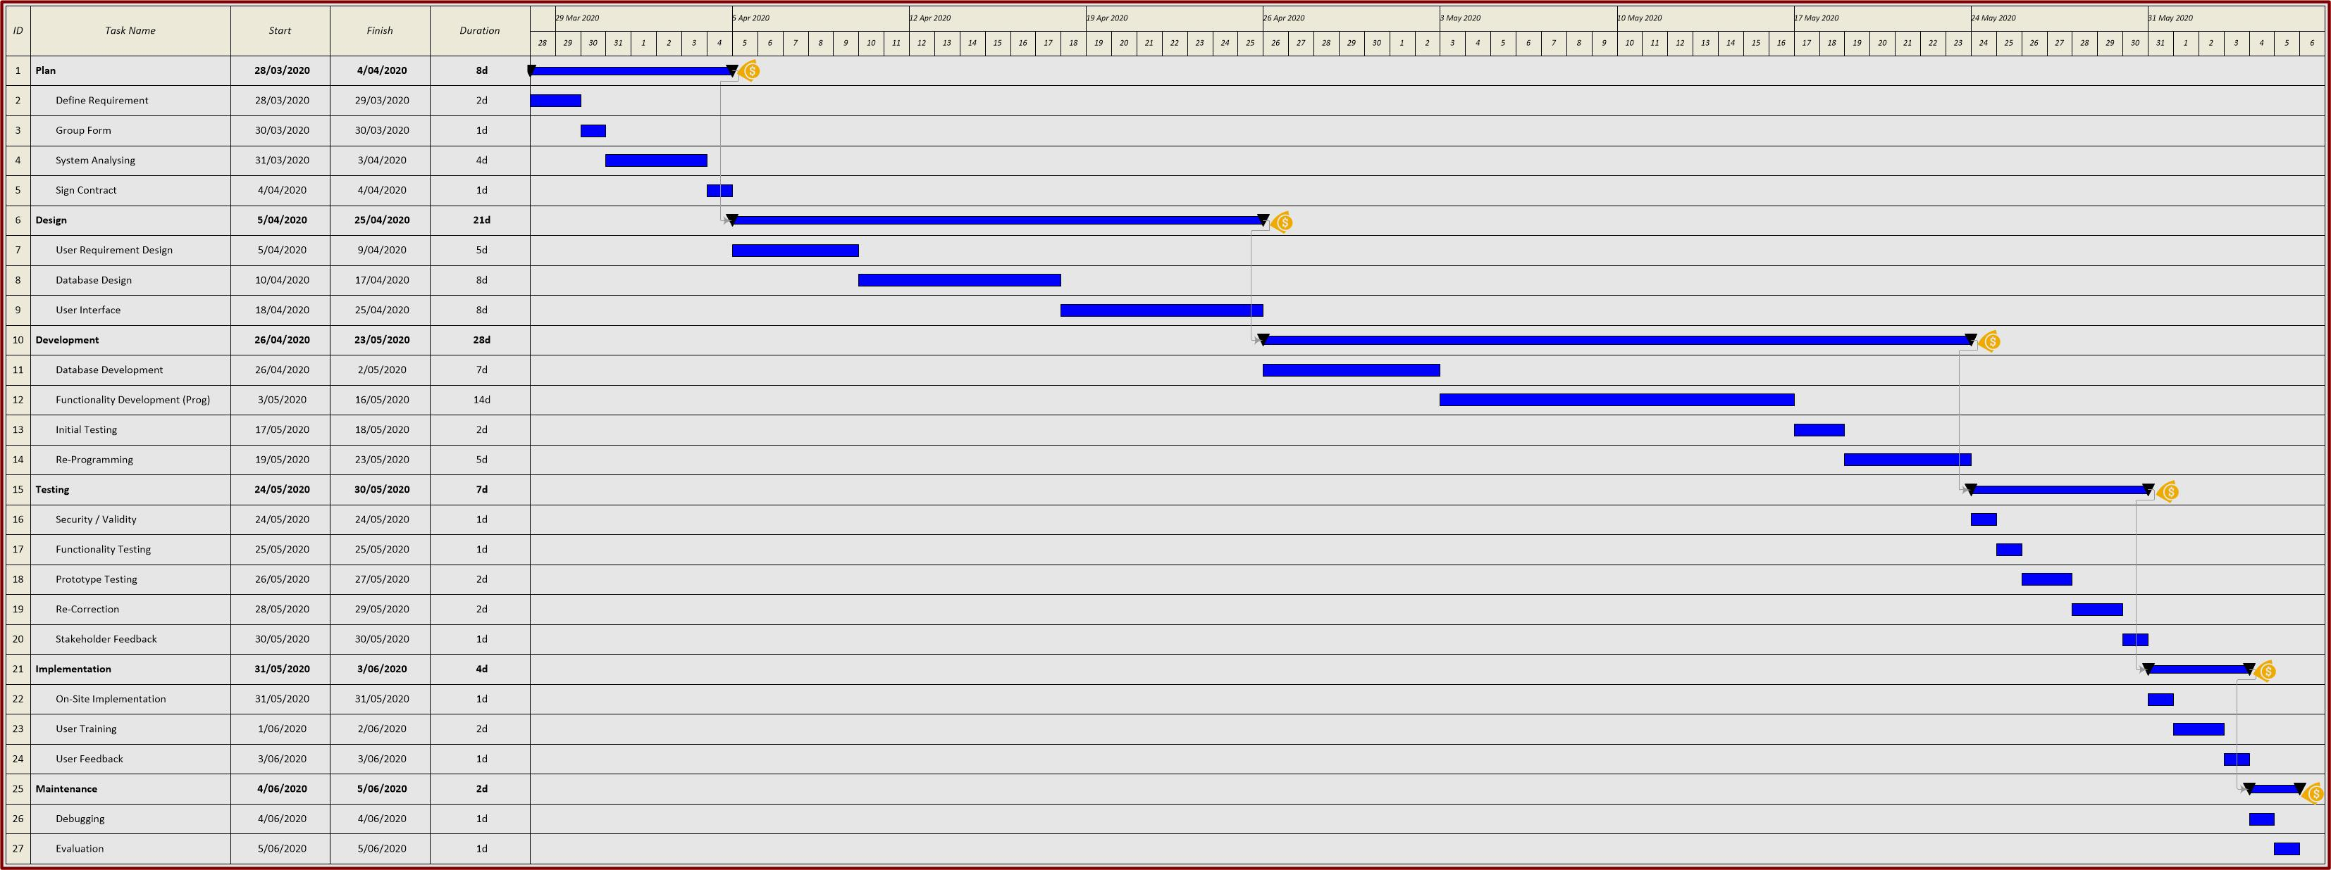

# Risk Management

The Risk management process plays a vital role when it comes to the car rental company. We never know what sorts of problem arrives when it comes when renting a car and we have to be caution with the online payment methods as there exists credit card frauds while renting a vehicle. So, it is very important to understand the risk factors and the coverage during the crash.

The risks that we have to face while designing and after the completion of the project are as follows:

* Privacy of the information
* Online security
* Customer Disputes
* Data validity
* Online payment or Card fraud